Activity 5.3: Automating a home
Imagine you have been asked to design a home automation system by a property developer.
Look at the floor plan of a home and:
- identify at least one automation for each different type of room
- identify the trigger(s), condition(s) and action(s) for each automation
- explain how each automation will help the people living in the home.

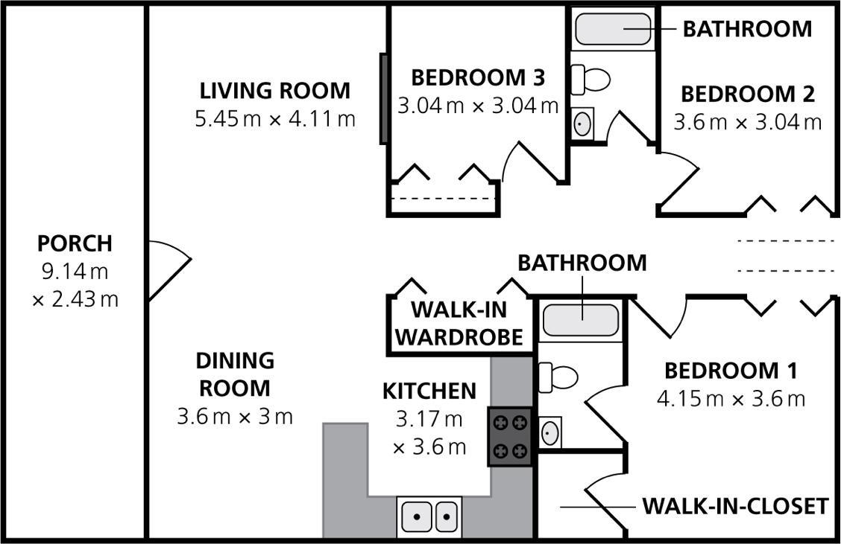

Use the following success criteria to ensure you have included all the required information for each room.
Success criteria | Bedrooms 1 and 3 | Bathroom | Walk-in wardrobe | Kitchen | Living room | Dining room | Porch

Automation described
Trigger(s) identified
Condition(s) identified
Action(s) described
How it helps people living in the home described

